**Infor Cash Management Chart**

The Infor **Cash Code** and **Bank Transaction Code** will drive the account creation in MHC Document Express and the Electronic File Name processes ran in Infor and imported into MHC. The information to complete this chart can be completed by going to your Infor CSF **Cash Management** Setup after you have created all your Cash Codes and Bank Transaction Codes.

**NAVIGATION:**

* Financials > Cash Management > Cash Setup > Cash Payment Formats
* Financials > Cash Management > Cash Setup > Cash Codes
* Financials > Cash Management > Cash Setup > Bank Transactions Codes

|  |  |  |  |  |  |  |  |
| --- | --- | --- | --- | --- | --- | --- | --- |
| **AP CHECK PRINTING** | | | | | | |  |
| **INFOR CASH CODE** | **INFOR BANK TRANSACTION CODE - PAYMENT TYPE** | **COMPANY**  **NAME** | **INFOR COMPANY #** | **BANK**  **NAME & ADDRESS** | **BANK**  **TRANSIT #** | **BANK**  **ACCT #** | **BANK**  **FRACTIONAL NUMBER**  **(See old Check)** |
|  |  |  |  |  |  |  |  |
|  |  |  |  |  |  |  |  |
|  |  |  |  |  |  |  |  |
|  |  |  |  |  |  |  |  |
|  |  |  |  |  |  |  |  |

|  |  |  |  |  |  |  |  |  |
| --- | --- | --- | --- | --- | --- | --- | --- | --- |
| **AP ACH & PAYCARD PROCESSING** | | | | | | | | |
| **INFOR CASH**  **CODE** | **INFOR BANK TRANSACTION CODE - PAYMENT TYPE** | **COMPANY**  **NAME** | **INFOR COMPANY #** | **BANK**  **NAME** | **BANK**  **TRANSIT-ROUTING #** | **BANK**  **ACCT #** | **ACH COMPANY ID #**  (This number is assigned by the Bank for each Account # you process) | **ACH FILE**  **ID #**  (This number is assigned by the Bank for each Account # you process) |
|  |  |  |  |  |  |  |  |  |
|  |  |  |  |  |  |  |  |  |
|  |  |  |  |  |  |  |  |  |
|  |  |  |  |  |  |  |  |  |
|  |  |  |  |  |  |  |  |  |

**STEPS TO PASSWORD PROTECT:**

1. Choose **File** drop down
2. Choose the **Protect Document** button next to Permissions

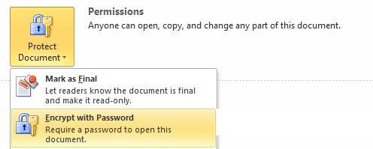

1. Choose **Encrypt with Password** and enter a password when prompted.
2. Hit **Save** and Close the document (Reopen the document to verify the password works).